The Cost of Justice in the European Union:
An budgetary analysis of the performance of the Court of Justice of the European Union

Prof. Dimitrios V. Skiadas, MJur, PhD
Jean Monnet Chair on Budgetary Governance in the EU and Audit
Dept of International and European Studies – University of Macedonia (GR)
156, Egnatia Street, 54636, Thessaloniki, Greece
dskiadas@uom.edu.gr

Abstract: The economic impact of a well-functioning justice system has been verified in various studies identifying the strong correlations between the improvement of court efficiency and the growth rate of the economy, and businesses’ perception of judicial independence and the growth in productivity. Thus examining the relevant performance of the Court of Justice of the European Union (CJEU) is a very interesting exercise. This examination focuses on its case management process, in particular whether the procedures in place promote the efficient handling of the cases lodged and whether their timely resolution could be enhanced. The assessment and accountability tools in place at the CJEU are also examined. The examination’s findings will feed some future considerations in view of the possible roles of the CJEU in the EU institutional regime.

Keywords: Budgetary Analysis, Court of Justice, European Union, Performance

Introduction

The European Union has been established as a Union “founded on the values of respect for human dignity, freedom, democracy, equality, the rule of law and respect for human rights, including the rights of persons belonging to minorities. These values are common to the Member States in a society in which pluralism, non-discrimination, tolerance, justice, solidarity and equality between women and men prevail.” (see Art. 2 of Treaty on European Union-TEU). Thus, the concepts of justice, rule of law, and respect for human rights are in the core of the Union’s statutory regime. In most regimes the institutional “arm” recognized as the competent scheme for interpreting law, determining the legality and breadth of statutes as well as the proper implementation of laws, the violation of laws and the consequences of such violations is the judicial branch, the courts [1]. In the European Union context, this institutional “arm” is, according to Art 13 TEU and Art 19 TEU, the Court of Justice of the European Union, which is entrusted with ensuring “that in the interpretation and application of the Treaties the law is observed” by providing rulings on actions brought by Member States, EU Institutions, and natural and legal persons as well as preliminary rulings on the interpretation of EU law and the validity of acts adopted by EU Institutions. The details on the organization, membership and functions of the Court of Justice of the European Union (CJEU) are provided for in Articles 251-281 of the Treaty on the Functioning of the European Union-TFEU.
The current wording of all these provisions has been formulated through the amendments that the Lisbon Treaty introduced to EU primary law, when this Treaty came into force in 2009. This wording, however, does not reveal the extent of the importance of the role that the CJEU performs within the EU, a role which can be summarily identified as ensuring that EU law is uniformly interpreted and applied in all Member States to ensure a level playing field for all economic and social actors (businesses and citizens), allowing them to enjoy the full benefits of EU law. Given this role, there are prerequisites that must be adhered to, even if they are complicated in a multinational environment such as the EU. All courts ought to deal with matters before them in a timely manner, with consistency, and their decisions ought to be accessible to those subject to their jurisdiction. The EU, with a membership of 28 states, its population exceeding 513 million citizens speaking 24 official languages, and encompassing various legal systems and histories, poses a real challenge in adjudicating on cases and contributing to building a body of law (an acquis) applicable in all these states, in an legitimate manner, accessible to and understandable by the EU citizens [2].
Meeting this challenge has caused extensive concerns, most of which focus on the capacity of the CJEU to fulfil its duties in a manner appropriate to its stated mission and position in the EU institutional system. And these concerns have derived from a very interesting and continuously developing background on examining the cost of justice and evaluating the courts’ performance throughout the world and through various specters.

The Debate on the Cost of Justice and the Courts’ Performance

Before entering into a more substantive analysis, it is necessary to provide some definitions that clarify concepts with similar meanings. These definitions are well established from the early 20th century throughout the global judicial framework. Thus, the term “Costs” is used to describe those items paid to a party in litigation, generally in partial compensation for his expenses, but occasionally intended rather as a penalty upon his opponent. Considered in the compensatory aspect, they seldom bear the slightest relation to the party's expenses. The term “Fees” is used to describe the sums which a litigant must pay to a court or a public officer in connection with some step in the litigation or for the rendition of some specific service. Originally they were compensatory to the officer who rendered this service. Today they generally accrue to the state and bear no substantive relation to the expense of the service rendered. Finally the overall cost of seeking judicial review or protection (mainly through litigation) is a quite different concept from "costs" and to avoid con- fusion, it is usually described by the term “expenses”. These expenses cover many elements, as they include fees, and, in cases of judicial defeat, costs. They also include compensation to counsel for his legal services, and all other out-of- pocket expenses involved in preparation for and the conduct of the trial and any appeal which may be taken, as well as all those intangible losses which result from the interruption of a party's business, from having capital tied up in litigation, and from the destruction of good will and good faith [3].
These definitions set the limits of the analysis in discussing the cost of justice and its various aspects, and they also pinpoint the stakeholders involved in the judicial process, affecting or being affected by the judicial system’s performance. First of all there is the community as a whole, the society within which justice is being delivered, and this community is concerned about the cost of justice, as this is represented by the remuneration of the counsel, the delays in the legal system, the vindication of people’s rights through due process, the formality of the courts. Then there are the branches of authority (legislative, executive, judicial), each of which has a significant role to play and the corresponding responsibility (for instance the legislature must avoid ill drafted bills and onerous provisions leading to awesome problems, the executive must avoid oppressive actions and be shift in carrying out its duties thus avoiding protracted litigation, the judiciary must deliver accurate and well documented judgments within reasonable time frameworks, etc). The lawyers, in turn, must provided their services in an appropriate, economic and cost-effective manner. Finally the individuals, the private citizens, must understand that they must use their common sense, obey the law and provide evidence for their arguments instead of pursuing fruitlessly cases, which leads to great expenses in terms of time and money. Thus, the enquiry into the cost of justice entails the quality of legislation, the structures and procedures by which it is administered and the parties involved in its formation and operation [4].
Given the historical course of developing the modern template of distribution of power in the various branches of an institutional regime (legislature, executive judiciary), most of the analysis on the status and performance of the courts has identified as an issue of immediate concern the design and use of mechanisms ensuring an accountable and impartial judiciary, and the trade-off between judicial independence and judicial accountability, especially in a democratic context. The factors that come into play in such an eventuality entail the method of selection of judges, their tenure of office, their removal for official misconduct, the institutional rules that protect decisional integrity, a legal/political culture that supports the rule of law, and the provision for adequate resources. This latter factor, entailing the budgetary means made available for the judiciary, has attracted significant interest as it focuses – in an overall sustained environment of scarce resources – on the judiciary’s financial needs to carry out its operations and on the fact that it relies on the executive and the legislative branches to provide this funding. The high cost of justice has been sometimes used as an excuse for not meeting judicial budget requests and allocating funding to other government activities, this being however, a pretext, in budget politics in order to influence the courts in their workings [5].
Nonetheless, it has been noted that, further to the above mentioned considerations, the organization of the court system and the rules under which it operates can have a dramatic impact on its effectiveness. Two main qualities have been identified as appropriate indicators for the courts’ effectiveness: the accuracy of a judgment and its timely delivery. Judicial “quality” is being measured by the impartiality of the judges, the adequacy of judicial resources, the efficiency of enforcement of rulings, the efficiency of judicial administration in general, the cost, ease of use and completeness of various judicial registries, and the adequacy of judicial operation on law and contract enforcement [6].
Using performance indicators to examine the added value of a judicial scheme is not a rare occasion. A performance indicator is a measurable value that demonstrates how effectively an entity is achieving its key objectives and, on many occasions, indicators such as the average case resolution output or the rate of cases brought forward from investigation services and passed on to the courts, have been employed as benchmarks for the execution of judicial duties, based on using the triangle workload-workforce-time as a suitable matrix to express performance. This quantitative approach is supplemented by qualitative elements as each individual case needs to be professionally assessed on its own merits. Law is a very sensitive field, affecting rights and obligations of an individual and even potentially touching upon an individual’s fundamental human rights, thus it would do ‘no justice to justice’ if there were only considerations based on a matrix of how much time a judge has to assess and decide upon an individual case. In this context, the use of performance indicators with regard to the judiciary serves three purposes: (i) to measure the efficiency of its operations; (ii) to identify areas that need additional scrutiny and improvement; and (iii) to effectively manage the judiciary’s resources. Beyond this, performance indicators have a triple effect: (i) internally they provide stability, control and transparent institutional goals, and can have a positive effect on the staff where managers use performance goals as something motivating and inspiring, rather than a ‘minimum standard’; (ii) externally they foster the institution’s legitimacy through accountability and transparency; (iii) from a budgetary point of view, performance indicators usually concentrate on the major cost drivers and provide a compelling narrative for budgetary needs – or show where potential inefficiencies lie if the narrative fails to convince the relevant stakeholders [7].
It is noteworthy that in the system of inter-institutional balance in a modern democracy, the third effect of the use of performance indicators, the budgetary implications of the judiciary’s performance, in terms of needs and results, has been very influential. The courts receive higher levels of funding when putting forward aggressive budgetary requests which are linked to the substance and the realities of their actual workload, thus increasing confidence to the reliability of the judiciary’s narrative regarding their needs. Evidence-based requests (using the relevant indicators) are deemed as the best possible means of the courts achieving their goals in securing their budgetary allocations to the desired level [1].
In addition to this budgetary approach, the cost of justice is being examined also through a monetary approach, entailing three elements. The first is the “loser pays” principle, which means that a defeated party should bare the other side’s (the victor’s) legal costs. It is an instrument of strict liability reflecting basic justice: responsibility for the winner’s costs rests with the party who brought or defended a losing cause. The second refers to economic access to justice. The topic of costs interacts with principles of access to justice both by claimants and defendants. Although justice must remain accessible, the risk of costs liability can have a chilling effect on legitimate claims, and it can operate oppressively so as to induce capitulation by defendants. Effective access to justice is a fundamental human right that is not theoretical or illusory but practical and effective, thus provisions permitting, for instance, “no win no fee” arrangements, must be enacted. The third element of costs, in a monetary point of view, is the interaction between costs awards and procedural discipline. The rule of costs shifting, in the event of defeat, can be a powerful deterrent of bad or spurious claims and defences. Also, costs orders can be adjusted to curb excessive, disproportionate, and unfocused development of a case and of peripheral issues. Costs rules can be used as sanctions against (i) unreasonable rejection of settlement offers made by the opponent and (ii) unreasonable rejection of mediation recommendations made by the court or mediation invitations made by the opponent [8].
Similar considerations have been put forward when examining the interaction between the budgetary constraints imposed on the judiciary and the option to offer alternative solutions (such as plea bargaining in criminal law cases) to resolve cases before they are trialed in the courtrooms. Such methods are viewed as essential tools for managing large case loads, as they reduce the cost of trails and the amount of time spent in court by all actors concerned (judges, prosecutors, counsels, administrative personnel, etc). However the excessive use of such tools may erode the effectiveness of the legal consequences included in legislative provisions, especially if these consequences have the form of sanctions. These tools are characterized by actions which lead to an agreement between the litigants on the division of the benefits created by avoiding the trial procedure. Each side of the dispute will benefit, as the victorious party will claim victory and vindication of his rights or his point of view and the defeated party will suffer reduced sanctions as consequence of his “cooperation”. Thus although the procedural aspect of justice might have been served in terms of reducing its monetary or overall economic cost, the substantive aspect of justice, the social demand on “putting things right” might not have been served as the defeated party might be either mistreated in principle (for instance an innocent party being convicted) or receive an otherwise inexcusably reduced sentence for a very serious offense [9].
Against this background of concerns regarding the factors affecting the cost of justice and the performance of the judicial institutions, it should not come as a surprise that in the context of the European Union, an entity with very high standards on its understanding and delivering of justice, there have been worries on the capacity of its judicial system, in terms of its cost and its performance.

The first concerns on the cost and performance of Justice in the European Union

Given the substantive content of the European integration experiment, which entails, the establishment and proper function of a common market, through “the elimination of all obstacles to intra-Community trade in order to merge the national markets into a single market bringing about conditions as close as possible to those of a genuine internal market” (see Judgment of the Court on Case C-15/1981, Gaston Schul Douane Expediteur BV v Inspecteur der Invoerrechten en Accijnzen, Roosendaal, European Court Reports 1982, p. 1409 at p. 1431-1432, ECLI:EU:C:1982:135), the EU judicial system has evolved to one of the most important factors affecting the potential of achieving the Union’s primary objective. Either in the form of a mechanism of judicial review regarding the protection of rights, or in the form of a mechanism of dispute resolution on cases pertaining the involvement of various institutional actors, the CJEU has been acknowledged as a crucial element of an integrated scheme, designed to uphold the principles of the rule of law and, at the same time, to operate as the appropriate forum of exchanging arguments and examining points of view, leading to a universally accepted outcome, in the form of a judgment delivered by impartial, independent individuals, equipped with all the guarantees of the judiciary. The impact of the Court’s judgments on the lives of EU citizens, determining the extent of exercising the four fundamental freedoms of movement of persons, goods, services and capital, implementing equal treatment, fundamental rights, social rights, etc, has been found to be of paramount significance, as the correlation between the proper functioning of a judicial system and the performance of the overall economic system, at national or EU level, has been examined and established through the use of various indicators and statistical data, entailing the efficiency, quality and effectiveness of the judiciary and the value added, the turnover and the number of enterprises [10].
The above described position and role of the CJEU in the Union’s institutional system, as these were enhanced by the Lisbon Treaty, generated various concerns on the Court’s capacity to meet the relevant challenges, both in procedural and substantive terms.
One issue of concern refers to the organizational structure of the CJEU. It consists of two separate courts:
i) the Court of Justice (CJ) which is composed of 28 judges, one per Member State, and eleven Advocates General who assist the Court by presenting, with complete impartiality and independence, an ‘opinion’ in the cases assigned to them. The CJ delivers binding preliminary rulings on questions put forward by national courts on the interpretation of EU law, judgments on whether a Member State has fulfilled its obligations under EU law, judgments on the annulment of a measure (in particular a regulation, directive or decision) adopted by an institution, body, office or agency of the EU, judgments on the lawfulness of the failure of the institutions, bodies, offices or agencies of the EU to act, and judgments on appeal on points of law against judgments and orders of the General Court or requests to review decisions of the General Court on appeals against decisions of the Civil Service Tribunal. It operates in various formations.
ii) the General Court (GC), composed of 56 judges, at least two from all Member States (now serving 46 Judges). The GC delivers judgments on direct actions brought by natural or legal persons against acts of the institutions, bodies, offices or agencies of the EU (which are addressed to them or are of direct and individual concern to them) and against regulatory acts (which concern them directly and which do not entail implementing measures) or against a failure to act on the part of those institutions, bodies, offices or agencies, actions brought by the Member States against the Commission, actions brought by the Member States against the Council relating to acts adopted in the field of state aid, ‘dumping’ and acts by which it exercises implementing powers, actions seeking compensation for damage caused by the institutions of the EU or their staff, actions based on contracts made by the EU which expressly give jurisdiction to the GC, actions relating to Community trademarks, appeals, limited to points of law, against the decisions of the Civil Service Tribunal, and actions brought against decisions of the Community Plant Variety Office or of the European Chemicals Agency. It operates in various formations.
Until 2016, there was also a specialized court, the Civil Service Tribunal (CST), composed of 7 judges, selected on a geographical basis by the Council of the EU. It operated in various formations and it delivered judgments on disputes between the EU and its servants pursuant to Article 270 TFEU. However, despite its good performance in carrying out its mandate, the CST was dissolved on 1.9.2016, and its work was subsumed into the GC, as part of the overall reform of the CJEU which aimed at increasing the size of the GC [11].
Although the use of such schemes of multiple courts, with various formations, each competent for a specific area of cases, in a single jurisdiction, nowadays is seen as an appropriate solution for the adjudication of cases with a specialized content, this has not always been considered as the best possible choice. The mere enumeration of such courts with their officers provides an indication of the confusion in the public mind as to their several jurisdictions, the number of their functionaries, and the expense they are to the taxpayer and to the litigant. Furthermore, the procedures entailed in the selection of their membership, either at national or European level, do cause concerns on the “promotion” of the various candidates, their behaviour and effort to seek support and form alliances, thus creating a “blurring” picture, especially in the eyes of the average citizen, with regard to the final selection [12].
But it was the function of the CJEU which provoked one major review on its performance. More specifically, the workload statistics presented in the Court’s 2009 Annual Report and the impact of the Treaty of Lisbon which expanded its jurisdiction in the area of Freedom, Security and Justice along with the increase to the membership of the EU from 15 to 25 states in 2004 and then to 27 states in 2007 and to 28 states in 2013, formed the basis of a detailed examination of the CJEU’s performance by the British House of Lords (EU Committee), which took place at two stages, the first in 2011 and the second in 2013. The resulting reports provided very useful conclusions which can be summarized as follows [2], [13]:
- The workload of the CJ and the GC was estimated to increase significantly, reaching critical levels, and the managerial ability of both Courts was called into question, especially in view of the risky to effort to find the right balance between the length of time it takes for the Courts to dispense with a case and the quality of their judgments in order to preserve their credibility.
- No concerns were identified with to the CST’s workload and its managerial ability in that respect.
- Despite the fact that the CJEU’s working language regime should not change, there should be an increased effort to provide the Court’s case law in all EU’s official languages, through enhanced translation services, as this is an element of its legitimacy (all EU citizens should be able to understand its judgments).
- The enactment procedure of EU legislation should include some form of impact assessment on the CJEU caseload, especially since the creation of an entire array of new EU executive agencies has increased the possibility of judicial challenges of their actions before the Court.
- The number of Advocates General should be increased as this will increase the speed with which cases can be dealt, and will improve the quality of decision-making (at the time of the reports there were eight and their number was subsequently increased to eleven).
- Financial assistance should be provided to the GC in order to establish a facility entailing the preparation, publication and monitoring of timetables charting a case’s progress, as a means for better case management.
- The membership of the GC should be increased as the best possible and most flexible long-term solution to address the problem of the GC’s caseload and the relevant cost should be covered by the EU budget, as, given the central role fulfilled by the Court in the effective operation of the Union, the benefits of such a change would clearly outweigh the costs for the Union (at the time of the reports there were 28 Judges at the GC, and in 2016 there has been a reform providing for the possibility of a membership of 56 Judges for the GC).
These conclusions were confirmed, in their predictions, by the problems that the CJEU had to face in discharging its duties. It is noteworthy that the CJEU has had to deliver judgments condemning the EU for not providing proper judicial services in terms of excessive time length of proceedings.

The case law on the EU’s responsibility for excessive time length of proceedings

The timely adjudication on a pending case has been traditionally seen as one of the main characteristics of the right to a fair trial, as this is established in various legislative documents, especially at European level, the most notable being the European Convention on Human Rights (for the relevant analysis in this context see for instance [14], [15], 16]), and the Charter of Fundamental Rights of the European Union (for the relevant analysis in this context see for instance [17], [18], [19]). Therefore, it should not come as a surprise that fact that the judicial system of the EU has been examined with regard to its conformity to such legal standards and, ironically, the institution that was responsible for such an examination has been the CJEU itself. Some indicative cases include the following:
Case C-385/2007 P, Der Grüne Punkt – Duales System Deutschland GmbH v. Commission of the European Communities, European Court Reports 2009, p. I-6155, ECLI:EU:C:2009:456
In that case the CJEU found that the length of the proceedings before the Court of First Instance of the EU (CFI-the predecessor of the General Court) when adjudicating on it (the substance of the case referred to the use of logos and the implementation of EU trademark legislation), which amounted to approximately 5 years and 10 months, could not be justified by the circumstances of the case, thus resulting to a procedural irregularity. However, as the substance of the case was not about the failure of the CFI to adjudicate within a reasonable time, and as this failure did not have any effect on the substantive outcome of the dispute, the relevant plea was rejected.
Case C-40/2012 P, Gascogne Sack Deutschland GmbH v. European Commission, ECLI:EU:C:2013:768, and
Case C-58/2012 P, Groupe Gascogne SA v. European Commission, ECLI:EU:C:2013:770
In those cases, which had the same factual basis, the CJEU found that the length of the proceedings before the GC when adjudicating on them (the substance of the cases referred to the implementation of EU competition law and the establishment of cartels), which amounted to approximately 5 years and 9 months, was not justifiable under the various circumstances of the case and this failure of the GC to adjudicate within a reasonable time was a serious breach of EU Law. However, claiming compensation for damages caused by such breaches entails another procedure which constitutes a separate legal action, thus within the framework of the judgment in question the relevant ground of appeal was rejected.
Joined Cases C-138/2017 P and C-146/2017 P, European Union v. Gascogne Sack Deutschland GmbH and Gascogne SA, ECLI:EU:C:2018:1013
In those cases, the CJEU was called to adjudicate on appeals put forward the European Union, as a legal entity, represented by the CJEU itself, regarding a judgment of the GC (Case T-577/2014) which awarded compensation to the companies involved in those cases, as a result of the breach of the obligation of the GC to adjudicate within a reasonable time in other cases (Cases T-72/2006 and T-79/2006). The CJEU found that the judgment of the GC was mistaken in establishing not the delay in delivering the judgments on the other cases but the causal link between that delay and the damages actually suffered by the companies involved in those cases. Furthermore, the CJEU itself examined the details of all the cases concerned and found that no actual substantive causal link could be established between the delay of the GC in delivering its judgment and the damage suffered by the companies involved in those cases.
Case C-150/2017 P, European Union v. Kendrion NV, ECLI:EU:C:2018:1014
In that case, the CJEU was called to adjudicate a) on an appeal put forward the European Union, as a legal entity, represented by the CJEU itself, regarding a judgment of the GC (Case T-479/2014) which awarded compensation to the companies involved in those cases, as a result of the breach of the obligation of the GC to adjudicate within a reasonable time in another case (Case T-54/2006), and b) on an cross appeal by the company involved claiming that the compensation awarded in Case T-479/2014 was less than appropriate and seeking more compensation. Before examining the substance of the case, the CJEU addressed an interesting argument put forward by the company involved in the case, that there was a conflict of interests as the CJEU (representing the EU) refers the matter to itself by an appeal, thus infringing the standards of independence and impartiality for adjudicating on cases. In the CJEU’s point of view, its status as an EU institution provided it with specific competences and jurisdiction to adjudicate such cases, while being the EU institution that was at the origin of the alleged damage lead to the Court representing the EU in the particular case. This situation did not result from a choice by the Court or the EU, but from the strict application of the EU Law rules on the matter. With regard to the substance of the case, the CJEU found that the judgment of the GC was mistaken in establishing the direct causal link between that delay in delivering the judgments on the other case and the damages actually suffered by the company involved in that case. Furthermore, with regard to the cross-appeal, the CJEU did not find any errors in the GC’s reasoning and it dismissed it. Finally, it decided to examine itself the details of the original case concerned and found that no actual substantive causal link could be established between the delay of the GC in delivering its judgment and the damage suffered by the company involved in that case.
Joined Cases C-447/2017 P and C-479/2017 P, European Union v. Guardian Europe Sàrl, ECLI:EU:C:2019:672
In those cases, the CJEU was called to adjudicate a) on an appeal put forward the European Union, as a legal entity, represented by the CJEU itself, regarding a judgment of the GC (Case T-673/2015) which awarded compensation to the company involved in those cases, as a result of the breach of the obligation of the GC to adjudicate within a reasonable time in another case (Case T-82/2008), and b) on an cross appeal by the company involved claiming that the compensation awarded in Case T-673/2015 was less than appropriate and seeking more compensation. The CJEU found that the judgment of the GC was mistaken in establishing the direct causal link between that delay in delivering the judgments on the other case and the damages actually suffered by the company involved in that case. Furthermore, with regard to the cross-appeal, the CJEU did not find any errors in the GC’s reasoning and it dismissed it. Finally, it decided to examine itself the details of the original case concerned and found that no actual substantive causal link could be established between the delay of the GC in delivering its judgment and the damage suffered by the company involved in that case.
Case T-725/2014, Aalberts Industries NV v European Union, ECLI:EU:T:2017:47
In that case, the General Court examined the application for compensation for damages of the company involved in case T-385/2006 (which referred to the implementation of EU competition legislation and the imposition of relevant sanctions), due to the delay of the GC in delivering its judgment within a reasonable time on that case. The GC found that the delay was caused by the factual and legal complexity of the case in question as well as the conduct of the parties involved in that case, thus there is not ground for unreasonableness and therefore no violation of EU Law.
It is interesting to note that in most cases, the main finding was that there was an unreasonably long period of time before the delivery of a judgment by the GC, however no causal link was established between this undeniable delay and the damage suffered by the companies involved in those cases. Thus the relevant claims for compensation were dismissed, on appeal. This legal result does not alter, in any case, the finding of the significant delays identified in the workings of the General Court of the CJEU.

The audit findings by the European Court of Auditors

The above described role and function of the judicial system of the European Union has attracted increased interest, given the point of view adopted on the need to strengthen the rule of law within the Union by promoting judicial reform at national and European levels and enhancing the relevant standards.
The respect for the rule of law, including the independence of justice systems, has a significant impact on the economy, especially with regard to investment decisions and attracting businesses, thus improving the effectiveness of justice systems has become a priority of the European Semester, the EU’s tool of economic policy coordination. There is a well- established link between, on the one side, the rule of law and effective justice systems and, on the other side, a business-friendly environment and economic growth. Thus, the Union requires from its member states to form or/and reform their national justice systems in order to meet specific standards. These standards are reflected by indicators on the efficiency of the judicial system (i.e. the length of proceedings, clearance rate and number of pending cases), the quality of the judicial system (i.e. accessibility, such as legal aid and court fees, training, monitoring of court activities, budget, human resources and standards on the quality of judgments) and the independence of the judicial systems (i.e. the perceived judicial independence among the general public and companies, on safeguards relating to judges and on safeguards relating to the functioning of national prosecution services) [20].
Given the importance of this approach, it would be unthinkable for the Union not to submit itself into similar exercises, aiming to improve the effectiveness of its own judicial system. The primary and secondary law of the EU provide that the CJEU must deliver justice of irreproachable quality, in a reasonable time, whilst as an EU institution also ensuring it uses the public funds at its disposal as efficiently and as effectively as possible, and according to the principles of sound financial management. Furthermore, as the quality and rapidity with which the CJEU delivers its decisions can have important consequences for individuals, legal persons, Member States and the EU as a whole, and any failure by the CJEU to adjudicate within a reasonable time may give rise to significant costs for the parties concerned, as well as direct costs to the EU budget for any damages arising from the excessive length of time taken, it is necessary to assess the performance of the Union’s judicial system, taking into account all these factors [21]. The institution responsible for the relevant auditing process is the European Court of Auditors (ECA), which presented its findings in a special report in 2017.
The scope of the audit was to assess whether the CJEU’s case management procedures resulted in efficient treatment of cases and whether they were resolved in a timely manner.
The findings of the ECA were quite revealing. The average duration in months of cases closed for the period 2006-2016 for the Court of Justice and the General Court were as follows:

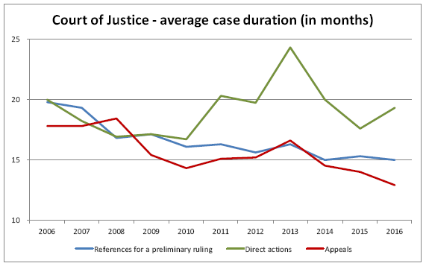
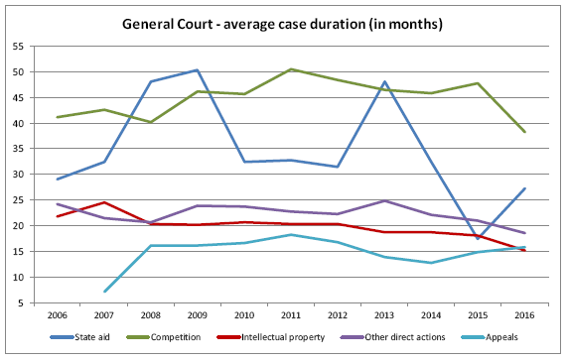
Figure 1: Average case duration (in months) for both CJEU formations
Source: European Court of Auditors, 2017, p. 14

A mere comparison of the data reveals the significant delays in the workings of the General Court, which have generated several claims for compensation for damages caused by these delays, such as those presented above.
The factors affecting the duration of the adjudication on a case refer to two stages. The first stage is the written procedure (lodging and initial processing) of the cases in the Registries of the Court of Justice and the General Court respectively, and the relevant factors are as follows:
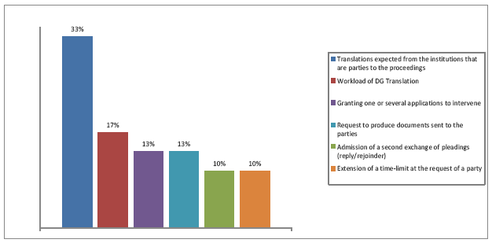

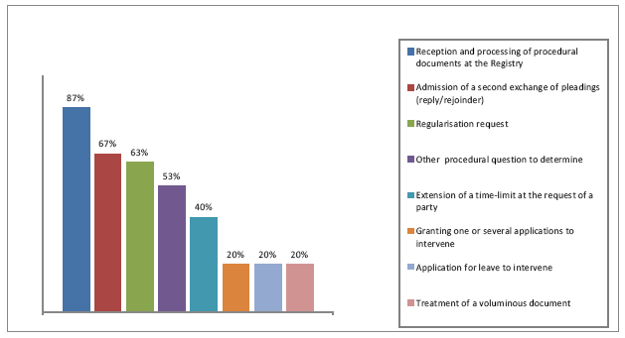
Figure 2: Factors affecting the duration of the written procedure for both CJEU formations
Source: European Court of Auditors, 2017, p. 27

The diversity of the reasons and the actual duration of this procedural phase depend on the Rules of Procedure, which set deadlines for the submission of the various procedural documents, as well as on the parties involved (requesting for example the extension of deadlines or the confidential treatment of certain information, or third parties requesting to intervene) [21].
The second stage entails the handling of the cases by the Chambers and Reporting Judges following their assignment, and the factor affecting its duration, for the Court of Justice and the General Court respectively, are as follows:
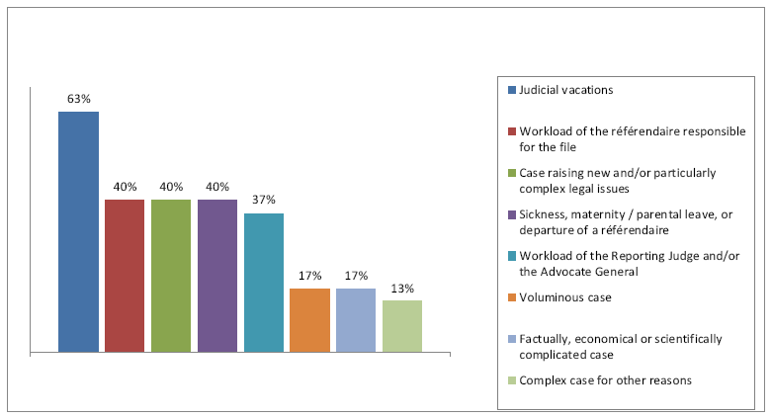

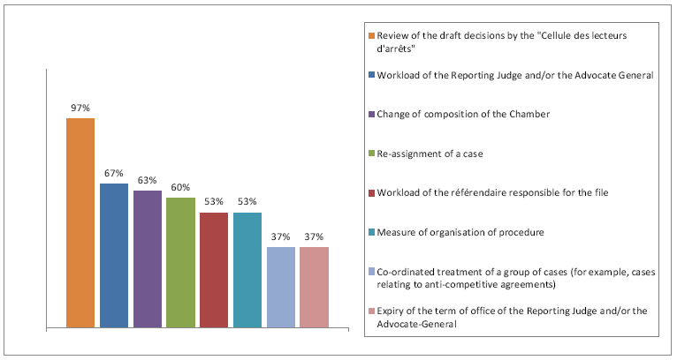

Figure 3: Factors affecting the duration of the handling of the cases following their assignment for both CJEU formations
Source: European Court of Auditors, 2017, p. 31-32

A comparison between the two judicial formations of the CJEU with regard to the factors named above, demonstrates that both formations have to tackle problems relating to the complexity of the substance of the case, the voluminous case documentation, the workload of the judicial personnel (especially in the case of the GC), the end of the judges’ mandate and the subsequent re-assignment of case, etc. However, the judges’ stated aim is to handle cases where possible within the indicative time-frames without compromising the quality of the work [21].
Another interesting finding refers to the systems and tools used by the CJEU in order to monitor and follow up the treatment of the cases. The statistical basis used refers to data such as the number of cases lodged, completed during the year and pending at the year-end, together with the average duration of proceedings closed during the year. This information is used by the CJEU to measure its own efficiency by assessing the evolution of the number of closed cases and by comparing, in particular for the Court of Justice, the average duration of closed cases to the indicative, one-size-fits-all, time-frames set for the various steps of the procedures. However, this management approach provides a global assessment of performance, and does not allow for monitoring proceedings against established standards based on the duration of cases tailored to their complexity and typology. Thus, since there is no information on the complexity of the cases concerned, an increase of the number of closed cases and/or a decrease in their average duration do not necessarily mean more efficiency [21]. In order to have more qualitative data, the ECA used standards set by a body called European Commission for the Efficiency of Justice (CEPEJ), which was established by the Council of Europe, in order to evaluate the time management schemes used by the CJEU and its findings were are follows:

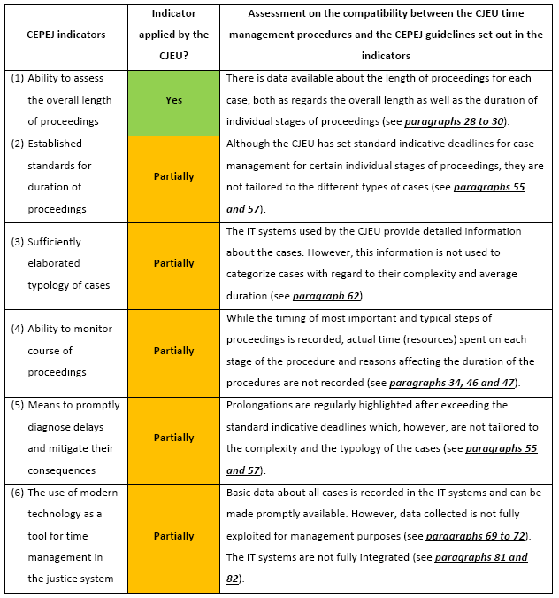
Figure 4: Extent to which the CJEU follows the most relevant CEPEJ guidelines relating to the “Time management check-list”
Source: European Court of Auditors, 2017, p. 39

Furthermore, the ECA examined the role of the translation in the case management process, identifying that the translation service also works toward a series of fixed time-frames combined with tailored deadlines. Thus it concluded that the translation element of the process significantly did not lengthen the overall case duration, with a significant number of translation tasks finished within the deadlines. Furthermore, the implementation of key performance indicators, which should allow inter-institutional comparisons to be made, is underway. On the contrary the IT infrastructure and systems in place at the CJEU are complex and rely on an ageing central data-base to which a large number of sub-systems have been added over time, thus depriving the CJEU from a fully integrated IT system to support case management. Changes to that system will limit the need for duplication, minimize the need for manual input and reduce the need to support a large number of applications. As for the working language regime (currently French), the CJEU aims to base its decision on a cost-benefit analysis to extend the language of deliberation to other languages as well [21].

Conclusions and Considerations for the future

It is unquestionable that the CJEU consists one of the pillars of the institutional structure of the European Union, and its operation is the catalyst for the Union’s capacity as an entity which upholds the rule of law and the fundamental principles of justice. And the continuous development of the European integration process will call upon the CJEU to undertake new roles, in accordance to the new fields of public policy that the Union will develop. One very characteristic example is in the area of criminal law and more specifically the protection of the EU’s financial interest by a new authority, the European Public Prosecutor Office (EPPO). Although Art.42 para 1 of the relevant Regulation 1939/2017 (OJ 2017, L 283/1), provides for the jurisdiction of the national courts on procedural acts by the EPPO, the CJEU is granted jurisdiction with regard to preliminary rulings on the interpretation of the relevant EU legislation, as well as to a series of administrative law disputes deriving from actions by that authority. More importantly, the derogation of Art. 42 para 3 of the same Regulation, which grants the CJEU the right to review the decisions of the EPPO to dismiss a case, in so far as they are contested directly on the basis of Union law, is a significant extension of the Court’s substantive mandate in a field which traditionally has been reserved for the exclusive jurisdiction of the national courts. This will make several of the considerations put forward on the impact of the operation of the national criminal courts on the cost of justice and the subsequent impact on the procedural rights of the persons involved in such proceedings in the European Union (see for instance [22]), more relevant to the function of the CJEU.
One of the most interesting conclusions of the analysis included in this paper is that fact that the needs and suggestions identified almost ten years ago, by the British House of Lords, with regard to the management of the case load of the CJEU, were, in their core substance, confirmed by the European Court of Auditors in its recent report. Taking into account the fact that, between the two reports, there has been a major reform of the CJEU (especially with regard to the General Court), the agenda for reforming the judicial institution of the EU has acquired a somewhat stable content, which is being updated, according to the developments in its various aspects.
Also, one cannot overlook the fact that several of the changes deemed necessary for the improvement of the CJEU’s performance, take a significant toll on the budget of the EU. In a period of severe economic constraints, which impose to all EU Member States to reach tough budgetary decisions, the EU should not undertake reforms without examining their financial and budgetary implications, and any additional costs should be minimized, based on their necessity. This approach was adopted with regard to the 2016 reform of the CJEU, as the net additional financial cost of the reform was estimated at €13.5 million yearly when fully implemented, or around 3.4% of the total budget of the CJEU [21]. It is an undeniable that a democratic regime, such as the one the EU claims to be, must take positive action (and undertake the corresponding expenses) in order to establish an judicial system (courts or other adjudicative schemes), to provide to its citizens not mere access to this judicial system, and to make sure that this system delivers effective “avenues of relief” for those seeking justice [23].

References

1. Hartley R. E. & Douglas J. M. (2003), Budgeting for State Courts: The Perceptions of Key Officials regarding the Determinants of Budget Success, The Justice System Journal, Vol. 24, pp. 251-263.
2. House of Lords – European Union Committee (2011), The Workload of the Court of Justice of the European Union, HL Paper 128, 14th Report of Session 2010–2011.
3. Dayton K, (1933), Costs, Fees, and Expenses in Litigation, The Annals of the American Academy of Political and Social Science, Vol. 167, The Administration of Justice, pp. 32-51
4. Cooney B. (1991) The cost of justice, Commonwealth Law Bulletin, Vol 17, issue 2, pp. 690-696, doi: 10.1080/03050718.1991.9986135.
5. Douglas J. M. & Hartley R. E. (2003), The Politics of Court Budgeting in the States: Is Judicial Independence Threatened by the Budgetary Process?, Public Administration Review, Vol. 63, No. 4, pp. 441-454
6. Ball G. G. & Kesan J .P. (2010), Judges, Courts and Economic Development: the Impact of Judicial Human Capital on the Efficiency and Accuracy of the Court System, available online at https://editorialexpress.com/cgi-bin/conference/download.cgi?db_name=ALEA2010&paper_id=380, on 20.11.2019.
7. Ambach Ph. (2018), Performance Indicators for International(ised) Criminal Courts – Potential for Increase of an Institution’s Legacy or ‘Just’ a Means of Budgetary Control?, International Criminal Law Review, Vol. 18, pp. 426-460.
8. Andrews N. (2014), Fundamentals of costs law: loser responsibility, access to justice, and procedural discipline, Uniform Law Review, Vol. 19, pp. 295–307, doi:10.1093/ulr/unu008
9. Mongrain S. & Roberts J. (2009) Plea bargaining with budgetary constraints, International Review of Law and Economics, Vol. 29, pp. 8–12.
10. Bove V. & Elia L. (2017), The judicial system and economic development across EU Member States; EUR 28440 EN, Publications Office of the European Union, doi:10.2760/449912, JRC104594
11. Butler G. (2019), An Interim Post-Mortem: Specialised Courts in the EU Judicial Architecture after the Civil Service Tribunal, International Organizations Law Review, vol. 16, pp. 1-47, doi: 10.1163/15723747-2019010
12. Loesch Fr. (1933), Reducing the Cost of Justice, National Municipal Review, Vol. 22, pp. 427-430.
13. House of Lords – European Union Committee (2013), The Workload of the Court of Justice of the European Union: Follow-Up Report, HL Paper 163, 16th Report of Session 2012–2013.
14. Roagna I, (2018), The right to trial within reasonable time under Article 6 ECHR - A practical handbook, Council of Europe, Strasbourg.
15. Edel Fr. (2007), The length of civil and criminal proceedings in the case-law of the European Court of Human Rights, Human Rights Files No. 16, Council of Europe Publishing.,
16. Vitkauskas D. & Dikov Gr., (2012), Protecting the right to a fair trial under the European Convention on Human Rights, Council of Europe Human Rights Handbooks.
17. Rodrigo S.G. (2015), The right to a fair trial in the European Union: lights and shadows, Revista de Investigações Constitucionais, vol. 2, issue n. 2, pp. 7-29.
18. Gutman K. (2019), The Essence of the Fundamental Right to an Effective Remedy and to a Fair Trial in the Case-Law of the Court of Justice of the European Union: The Best Is Yet to Come?, German Law Journal, Vol. 20, issue no 6, pp. 884-903.
19. Aalto P., Hofmann H., Holopainen L., Paunio E., Pech L., Sayers D., Shelton D., Ward A. (2014), Article 47 – Right to an Effective Remedy and to a Fair Trial, in Peers St., Hervey T., Kenner J., Ward A. (Ed.), The EU Charter of Fundamental Rights A Commentary, Nomos, Baden-Baden, pp. 1240 – 1319.
20. European Commission (2019), The 2019 EU Justice Scoreboard, COM(2019)198/2, Luxembourg: Publications Office of the European Union.
21. European Court of Auditors (2017), Performance review of case management at the Court of Justice of the European Union, Special Report 14/2017, Luxembourg.
22. Ouwerkerk J. (2017), All ’bout the Money? On the Division of Costs in the Context of EU Criminal Justice Cooperation and the Potential Impact on the Safeguarding of EU Defence Rights, European Journal of Crime, Criminal Law and Criminal Justice, VOL. 25, pp. 1-10.
23. Holmes S. & Sunstein C.R. (1999), The Cost of Rights, Norton, New York.

